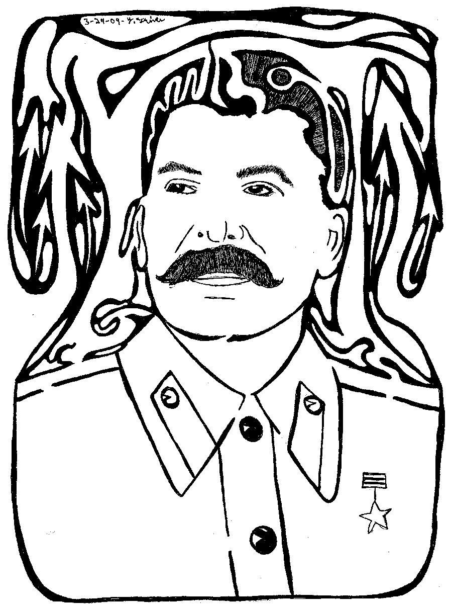
Joseph Stalin-Fill in the image with 10 symbols that represent his rule. On the back of this paper, explain what each symbol represents.

